ASSIGNMENT 1 – REPORT

# PART 1: Regression with Polynomial Basis Functions

Plot 1: Function and data points

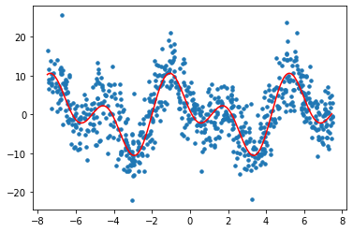

Plot 2: Splitting data points into train, test and validate sets

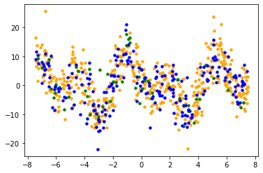

Plot 3: Validation error vs Test error

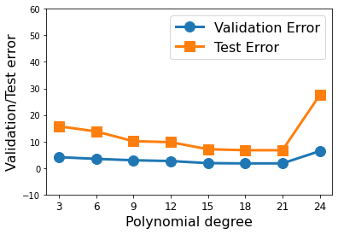

Model is best for d = 21

Plot 4: Visualization of each learned model

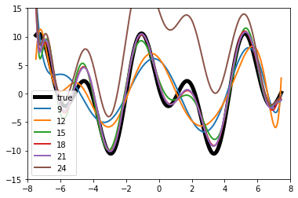

# PART 2: Regression with Radial Basis Functions

Plot 1: Validation error vs Test error

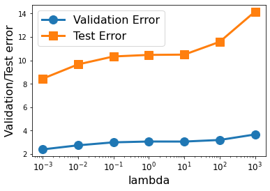

Model is best for lambda = 10^-3

Plot 2: Visualization of each learned model

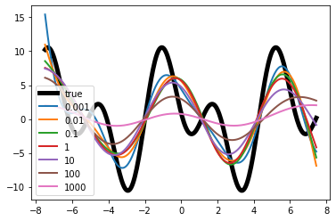

Plot becomes more linear as lambda increases.